[Subject] Special Announcement: The Australia Institute's new Executive Director
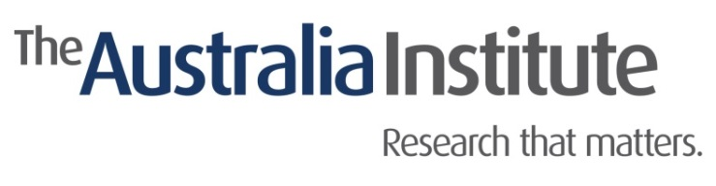
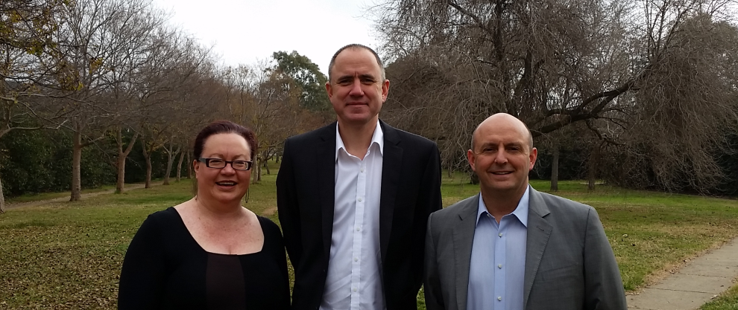
A message from the Chair of the Board
Dear {{ recipient.first_name_or_friend }} --

I am writing with some big and exciting news. After 8 years at the helm Richard Denniss has decided to step down from the role of Executive Director of the Australia Institute. On behalf of the Board I would like to express my appreciation to Richard and his family for the effort he has put in, and for the results that he has achieved.

As the Institute has grown in size, profile and impact Richard has found it increasingly difficult to focus on what he sees as his strengths of research and writing while managing a rapidly growing organisation that is at the heart of so many of the biggest debates. So it is with great pleasure that I can announce that Richard will take on the newly created role as The Australia Institute's Chief Economist.

But wait, there is more! I am very pleased to announce that Ben Oquist will step into the role of Executive Director. Ben was a long term member of the Board of TAI before taking on the role of Strategy Director 18 months ago. Ben has already played a transformative role in building stronger bridges between the Institute's research, the media and the parliament. The Board has worked closely with Richard and Ben over the past 18 months to manage this transition to ensure that The Australia Institute is well placed not just to talk about the future of Australia, but to shape it with our progressive values.

If you would like to join me in thanking Richard and welcoming Ben please let them know what you think their biggest successes or future priorities should be. I know they both appreciate feedback from our supporters.

Lin Hatfield Dodds, Chair, The Australia Institute

A word from Richard

Fifteen years ago when I first walked into the Australia Institute's old offices there were 4 staff, including me. I couldn't believe that I was standing in the same organisation that had told the world that Australia was the world’s biggest per capita emitter of greenhouse gas emissions and developed the Genuine Progress Indicator for Australia. We have always punched above our weight.

Since taking on the leadership of TAI in 2008 we have grown from 5 staff to 15. We are still tiny compared to most national organisations, and our entire budget is dwarfed by the stationary budget of the mining companies and banks that we so often debate. But I'm proud to say that, over time, the quality of our research trumps the quantity of their spin. How do we do it? It's much cheaper to tell the truth.

The Institute's staff are an amazing group of people. It has been an honour and a privilege to build and lead such a creative, supportive and hard working team of people. Democracy can only work when there is honest debate, and thanks to the efforts of the Institute's staff, and the generous support of our thousands of supporters, I've had a much better opportunity to participate in those debates than most. The football fans in the office often describe me as the full forward who gets to kick most of the goals. But I couldn't have done my job if there wasn't a whole team behind me. You can't do anything important by yourself.

Managing a team is a privilege, but it takes enormous time and energy to do it well. After 8 years at the helm I am excited about spending a lot more time researching and writing. I'm also excited about working under the leadership of my good friend Ben Oquist. I've never met anyone who is better at dissecting complex policy problems than Ben, and I have benefited enormously from his advice and support. I hope I can be as helpful to him as he has been to me.

The Australia Institute's entire agenda is based on the premise that Australians are a generous people who want to make the world a better place, not just for themselves, but for everyone. Every time we find a cheque in the mail or sign up a new monthly donor the staff of TAI are reminded that those who think the world is made up of selfish people who only act in self-interest are completely wrong. And, as you know, I love proving the economic rationalists wrong.

To the Institute’s Board, staff and supporters, thanks for a great ride. And never stop believing that evidence and ideas can make a difference. They can. They do. And thanks to your efforts, they have.

Richard Denniss, Chief Economist, The Australia Institute

A message from our new Executive Director

It’s an honour to work for one of Australia’s most important institutions, and I thank Lin and the board for placing their trust in me as Executive Director.

The Australia Institute is what it is to a large extent because of the incredible intelligence, energy and unique vision of my colleague and friend, Richard Denniss. I came to work here because of Richard. Thankyou for giving me and The Institute so much.

And the best news is that Richard’s not going anywhere! Undoubtedly one of the nation’s leading public intellectuals, as our new Chief Economist Richard will be writing and speaking more than ever.

The Australia Institute independent, fiercely non-partisan and barracks for ideas, not political parties. This can frustrate people from time to time. But we call it as we see it, and back our position with research of the highest quality.

In the last two weeks we welcomed the Greens’ support for pension reform, we welcomed Labor's move to undo Howard's fuel indexation decision, and both times we were endorsing key budget policies from the Liberal Party in areas that The Australia Institute had led the debate on. We were critical of the decision by Senate crossbenchers to repeal the carbon tax, but applauded moves by them to save the Renewable Energy Target, Clean Energy Finance Corporation, the Australian Renewable Energy Agency and improve the Government’s Direct Action scheme and revamp and fund the Climate Change Authority.

In order to make a difference, any think-tank has to be as much ‘tank’ as ‘think’. The Institute is a power house of ideas and thinking, but we also act to ensure our research has impact. This means connecting ideas to decision makers and engaging in and shaping the public debate.

The Australia Institute is the only think tank based in Canberra. We’re proud of that. The laws of Australia are made here. Most of the commonwealth public service is here. A critical section of the 4th estate is based here. This is the centre of our country's democracy. Despite popular sentiment, politics should not be a dirty word, for parliamentary democracy cannot function without it.

Working with Richard, Ebony, Rod and the whole team here is a massive privilege. Our small team is smart, nimble and incredibly hard working. This team exists because of the generous support of our members and donors. Thank you.

Looking forward to working with you,

Ben Oquist
Executive Director
The Australia Institute
PS. Don’t miss Richard’s devastating cover essay in The Monthly coming out this week. It demolishes Hockey and the Coalition's economic record. Richard again demonstrates the Institute’s role at the forefront of economic debate, challenging nonsense claims, dodgy modelling and the myth that the right are better economic managers.

